Name: G.Ganesh
Reg No: 192373008
Q1. Online Food Delivery App
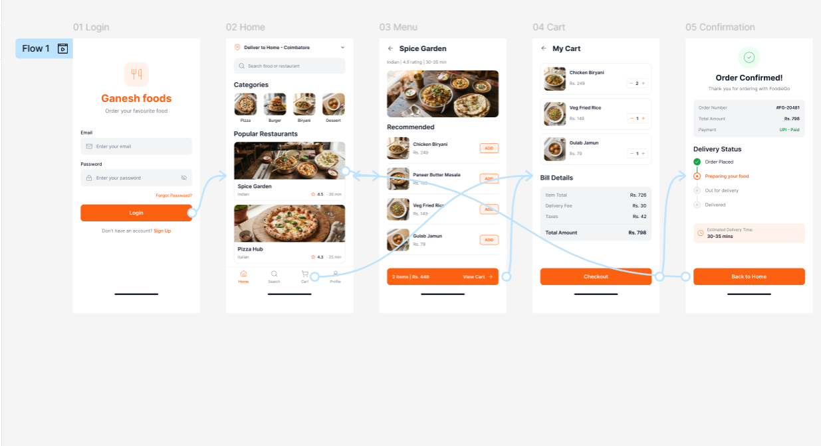
Q2. College Student Attendance App
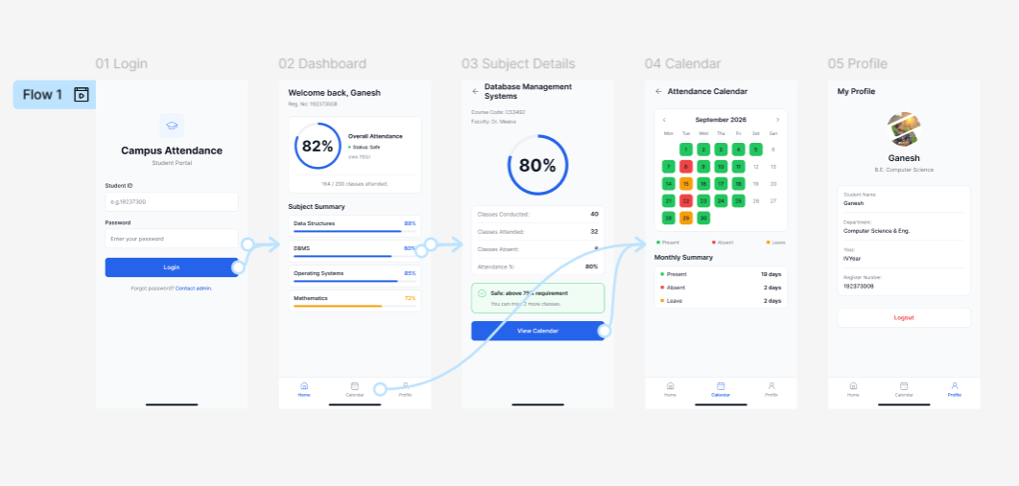

Q3. E-Commerce Clothing App
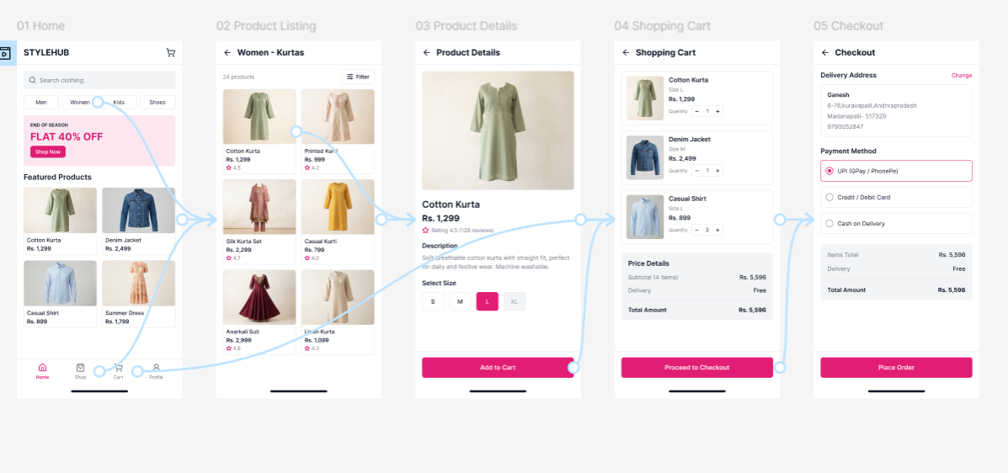
Q4. Hospital Appointment Booking
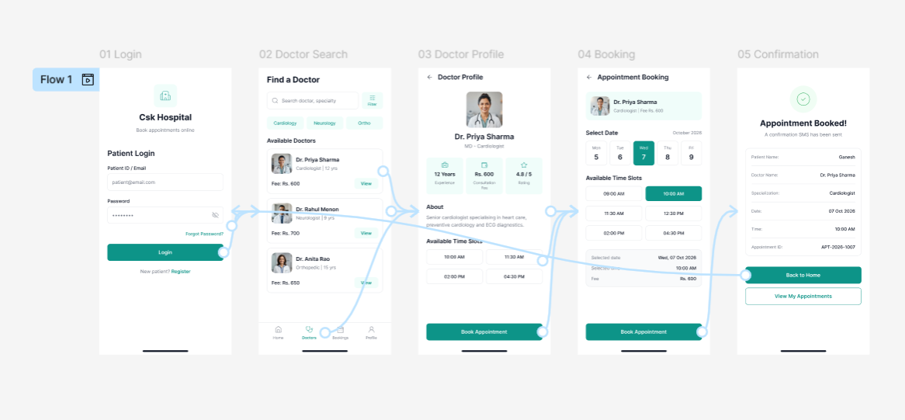

Q5. College Event Registration Website
